
SCHOOL OF COMPUTING AND ENGINEERING SCIENCES (SCES)
BACHELOR OF SCIENCE IN ELECTRICAL AND ELECTRONIC ENGINEERING
BEE 5235: Introduction to Vision and Robotics Lab 1
Representing Position and Orientation

By:
Edward Aribu
142092

Lecturer:
Martin Wachie Wafula
Strathmore University

March 2026

Contents
1. Title 3
2. Objectives 3
3. Introduction and Theoretical Framework 3
3.1 The Cartesian Coordinate System and the Right-Hand Rule 3
3.2 The Special Orthogonal Group SO(3) 4
3.3 Euler's Rotation Theorem 4
3.4 The Special Euclidean Group SE(3) and Homogeneous Transformations 5
3.5 Chasles' Theorem 5
4. Procedure 6
5. Results 7
5.1 Exercise 1: Completing Coordinate Frames via the Right-Hand Rule 7
5.2 Exercise 2: Homogeneous Matrix Analytical Inversion 8
5.3 Exercise 3: Coordinate Frame Assignment on a Spatial Block 11
5.4 Exercise 4: Kinematic Transformation of Displaced Coordinate Frames 13
5.5 Exercise 5: Second Frame Configuration 16
6. Discussion 19
7. Sources of Error 20
8. Conclusion 20
9. References 20
Appendix 21

1. Title
Representing Position and Orientation in Robotics

2. Objectives
The objectives of this laboratory exercise are:
- To understand how to use MATLAB to compute and represent positions and orientations of different coordinate frames and points.
- To understand and apply the right-hand rule to determine the direction of axes (X, Y, Z) in a right-handed coordinate system.
- To construct, manipulate, and analytically invert 4×4 homogeneous transformation matrices belonging to the Special Euclidean group SE(3).
- To apply foundational kinematic theorems, Euler's Rotation Theorem and Chasles' Theorem, to computational spatial models.
- To extract geometrical parameters from visual grids and diagrams and translate spatial relationships into rigorous numerical matrices.

3. Introduction and Theoretical Framework
In robotics, computer vision, and autonomous systems, the precise mathematical representation of a rigid body's position and orientation termed as its pose, is the foundation upon which all spatial reasoning is built. Whether the system is a multi-degree-of-freedom serial manipulator, a mobile autonomous platform, or a vision sensor, the system operates within a strictly defined physical workspace. A robust mathematical formalism is therefore required to describe geometric and algebraic relationships between sensors, actuators, and physical objects. This framework relies on linear algebra, group theory, and differential geometry.

3.1 The Cartesian Coordinate System and the Right-Hand Rule
The standard representation of three-dimensional space in robotics uses the Cartesian coordinate system. The universally adopted convention for axis orientation is the right-handed coordinate system. If the index finger of the right hand is extended along the positive X-axis and the middle finger along the positive Y-axis, the extended thumb points in the direction of the positive Z-axis.
Mathematically, this geometric convention is formalized through the vector cross-product. For a right-handed orthogonal basis with unit vectors î, ĵ, and k̂ aligned along X, Y, and Z respectively:
î × ĵ = k̂ , ĵ × k̂ = î , k̂ × î = ĵ
This constraint ensures the determinant of the basis matrix is exactly +1. A left-handed system, where î × ĵ = −k̂, has determinant −1, representing a spatial reflection that would cause maasive failures in path planning algorithms.

3.2 The Special Orthogonal Group SO(3)
The orientation of a rigid body is captured by a 3×3 direction cosine matrix R. All valid rotation matrices form the Special Orthogonal group:
SO(3) = { R ∈ ℝ³ˣ³ | RᵀR = I₃, det(R) = +1 }
Lemma 1 (Orthogonality of Rotation Matrices): For any R ∈ SO(3), R⁻¹ = Rᵀ. This property is exploited extensively in kinematic calculations as computing a transpose is computationally trivial compared to computing a full matrix inverse.
The elementary rotation matrices for a rotation by angle θ about the principal axes are:
Rotation about X: Rₓ(θ) =
[1, 0, 0
0, cosθ, −sinθ;
0, sinθ, cosθ]
Rotation about Y: R_y(θ) =
[cosθ, 0, sinθ
0, 1, 0
−sinθ, 0, cosθ]
Rotation about Z: R_z(θ) =
[cosθ, −sinθ, 0
sinθ, cosθ, 0
0, 0, 1]

3.3 Euler's Rotation Theorem
Theorem 1 (Euler's Rotation Theorem): Any displacement of a rigid body with at least one fixed point is equivalent to a single pure rotation about a fixed axis passing through that point.
Proof sketch: Let R ∈ SO(3). The theorem requires a non-zero vector n̂ such that Rn̂ = n̂, meaning n̂ is an eigenvector with eigenvalue λ = 1. To show det(R − I₃) = 0, observe:
det(R − I₃) = det((R − I₃)ᵀ) = det(Rᵀ − I₃) = det(R⁻¹ − I₃) = det(R⁻¹(I₃ − R)) = det(R⁻¹) · det(I₃ − R)
Since det(R⁻¹) = +1 and det(I₃ − R) = −det(R − I₃) for a 3×3 matrix, it follows that det(R − I₃) = −det(R − I₃), implying det(R − I₃) = 0. This guarantees λ = 1 is always an eigenvalue of any rotation matrix. Euler's theorem guarantees any sequence of rotations reduces to a single angle-axis representation, forming the basis for Rodrigues' formula, the matrix exponential map, and unit quaternions.

3.4 The Special Euclidean Group SE(3) and Homogeneous Transformations
Complete rigid-body motion requires both translation and rotation. The combination of a translation vector p ∈ ℝ³ and a rotation matrix R ∈ SO(3) defines the Special Euclidean group SE(3). To unify rotation and translation into a single linear matrix multiplication, homogeneous coordinates are introduced by augmenting the 3D position vector with a fourth component of 1.
Definition 2 (Homogeneous Transformation Matrix): A 4×4 matrix T ∈ SE(3) representing the pose of frame {B} relative to frame {A}:
ᴬTB = [ ᴬRB ᴬpB ; 0₁ₓ₃ 1 ]
where ᴬRB ∈ SO(3) is the 3×3 rotation submatrix and ᴬpB ∈ ℝ³ is the translation column vector.
Corollary 1 (Analytical Inverse of a Homogeneous Transformation): Given T ∈ SE(3), its inverse is:
T⁻¹ = [ Rᵀ −Rᵀp ; 0₁ₓ₃ 1 ]
Derivation: Setting TT⁻¹ = I₄ and solving by block multiplication yields RX = I₃ (so X = Rᵀ) and Ry + p = 0 (so y = −Rᵀp). This avoids the computationally expensive determinant-based inversion of a full 4×4 matrix.

3.5 Chasles' Theorem
Theorem 2 (Chasles' Theorem): Every general rigid body displacement in three-dimensional space can be represented as a translation along a screw axis followed by a rotation about that same axis.
The total translation vector p can be decomposed into a component parallel to the rotation axis n̂ (the screw pitch h = (v·ω)/||ω||²) and a perpendicular component that shifts the screw axis position to rₐ = (v × ω)/||ω||². This theorem underpins screw theory used in geometric modeling and control of robotic manipulators.

Table 1: Comparative properties of SO(3) and SE(3) matrix Lie groups.

Property | SO(3) | SE(3)
Dimensionality | 3 DOF (Roll, Pitch, Yaw) | 6 DOF (3 Translation, 3 Rotation)
Matrix Size | 3 × 3 | 4 × 4
Determinant | +1 | +1
Inverse | R⁻¹ = Rᵀ | T⁻¹ via block formula
Key Theorem | Euler's Rotation Theorem | Chasles' Theorem

4. Procedure
MATLAB software was used to compute the positions and orientations of different coordinate frames in this laboratory exercise. The specific procedures are outlined as follows:
- Visual Frame Analysis and Parameter Extraction: The orientation and spatial translation of multiple discrete coordinate frames were visually extrapolated from 3D orthogonal projection grids in the laboratory document. Grid increments were analysed to extract precise numerical position vectors.
- Right-Hand Rule Verification: For exercises requiring derivation of undefined axes from 2D planar projections, the right-hand rule was enforced via the vector cross-product, ensuring k̂ = î × ĵ.
- Homogeneous Transformation Matrix Construction: 4×4 matrices in SE(3) were assembled by mapping the unit direction vectors of the target frame onto the reference frame to form the rotation submatrix R, and extracting coordinate shifts as the translation vector p.
- Analytical Matrix Inversion: Inversion was performed using Corollary 1 (T⁻¹ = [Rᵀ −Rᵀp; 0 1]), deliberately avoiding blind software inversion to demonstrate mastery of SE(3) mechanics.
- Computational Validation: Results were verified using MATLAB functions including cross(), inv(), and transpose() to guarantee numerical accuracy.

5. Results

5.1 Exercise 1: Completing Coordinate Frames via the Right-Hand Rule
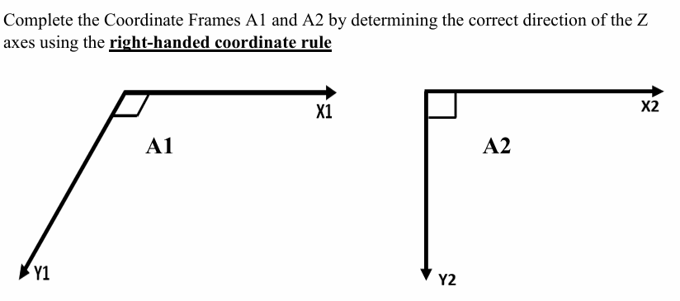

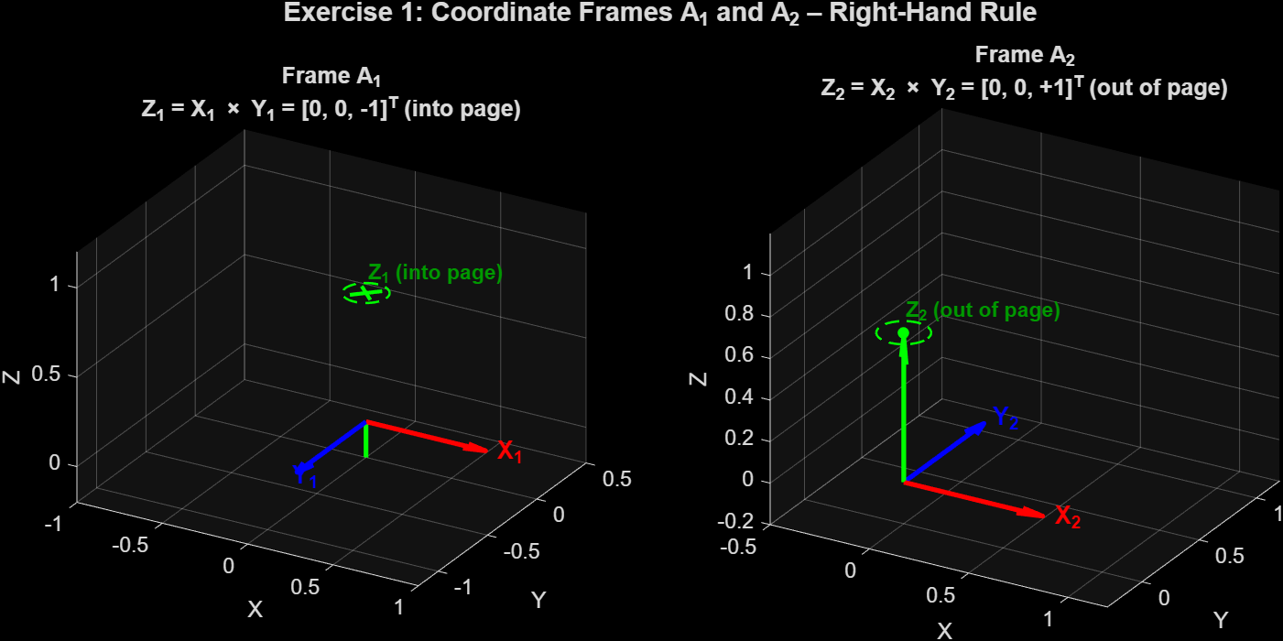
Figure 1

5.2 Exercise 2: Homogeneous Matrix Analytical Inversion
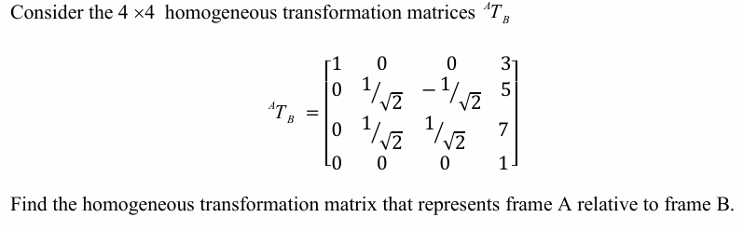Given forward matrix ᴬTB:
Extracting R and p, then computing Rᵀ and −Rᵀp:
Rᵀ =
[ 1 0 0
0 1/√2 1/√2
0 −1/√2 1/√2 ]
−Rᵀp = [ −3 −6√2 −√2 ]ᵀ
∴ ᴮTA =
[ 1 0 0 −3
0 1/√2 1/√2 −6√2
0 −1/√2 1/√2 −√2
0 0 0 1 ]
============================================================
Exercise 2: Homogeneous Transformation Matrix Inversion
============================================================
Given forward transformation matrix A_T_B:
1.0000 0 0 3.0000
0 0.7071 -0.7071 5.0000
0 0.7071 0.7071 7.0000
0 0 0 1.0000
Rotation submatrix R:
1.0000 0 0
0 0.7071 -0.7071
0 0.7071 0.7071
Translation vector p:
3
5
7
--- Verification that R ∈ SO(3) ---
R^T * R =
1.0000 0 0
0 1.0000 0
0 0 1.0000
det(R) = 1.000000 (should be +1)
Analytical Inverse B_T_A = inv(A_T_B):
1.0000 0 0 -3.0000
0 0.7071 0.7071 -8.4853
0 -0.7071 0.7071 -1.4142
0 0 0 1.0000
MATLAB built-in inv(A_T_B) (for verification):
1.0000 0 0 -3.0000
0 0.7071 0.7071 -8.4853
0 -0.7071 0.7071 -1.4142
0 0 0 1.0000
Max absolute difference between methods: 1.78e-15
Verification A_T_B * B_T_A (should equal I_4):
1 0 0 0
0 1 0 0
0 0 1 0
0 0 0 1
--- Component Breakdown ---
R^T =
1.0000 0 0
0 0.7071 0.7071
0 -0.7071 0.7071
-R^T * p = [-3, -8.48528, -1.41421]^T
Note: -6*sqrt(2) ≈ -8.4853, -sqrt(2) ≈ -1.4142

>>

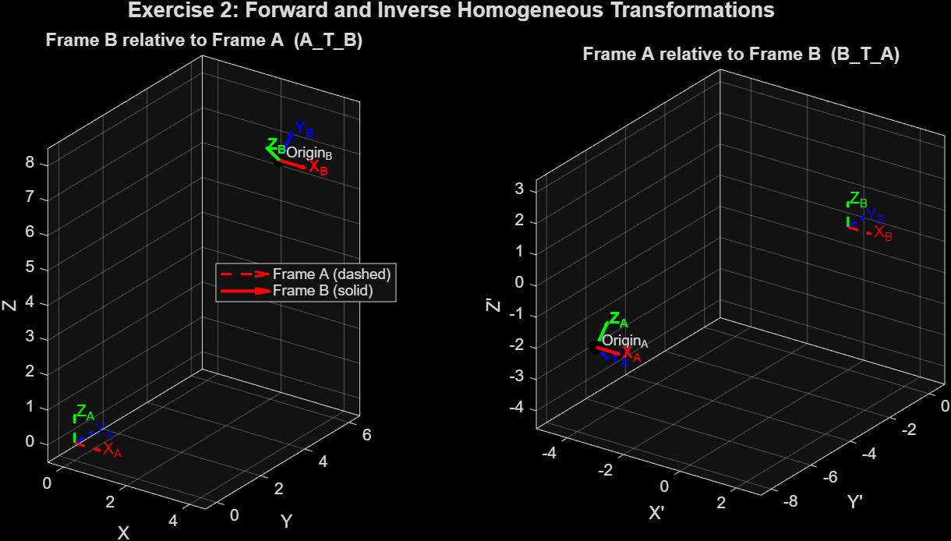
Figure 2

5.3 Exercise 3: Coordinate Frame Assignment on a Spatial Block
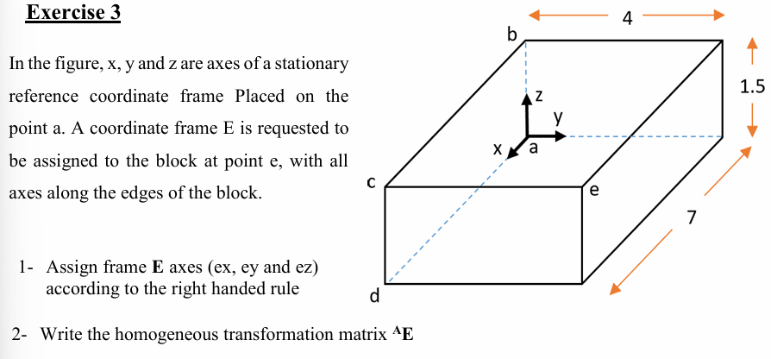
A coordinate frame E was assigned to point e on the rectangular block with axes parallel to its edges. The position of the origin of frame E is pE = (7, 4, 1.5) relative to frame A. Since the axes of frame E are parallel to those of frame A, there is no angular displacement and the rotation submatrix reduces to I₃:
ᴬTE =
1 0 0 7
0 1 0 4
0 0 1 1.5
0 0 0 1 ]
============================================================
Exercise 3: Frame Assignment on a Rectangular Block
============================================================
Block dimensions: Lx=7.0, Ly=4.0, Lz=1.5
Origin of frame E: p_E = (7.0, 4.0, 1.5)
Rotation submatrix R (identity - frames are parallel):
1 0 0
0 1 0
0 0 1
Homogeneous transformation matrix A_T_E:
1.0000 0 0 7.0000
0 1.0000 0 4.0000
0 0 1.0000 1.5000
0 0 0 1.0000
Inverse transformation E_T_A = inv(A_T_E):
1.0000 0 0 -7.0000
0 1.0000 0 -4.0000
0 0 1.0000 -1.5000
0 0 0 1.0000
Verification A_T_E * E_T_A = I_4:
1 0 0 0
0 1 0 0
0 0 1 0
0 0 0 1

Figure saved: figure_ex3_block_frame.png
>>

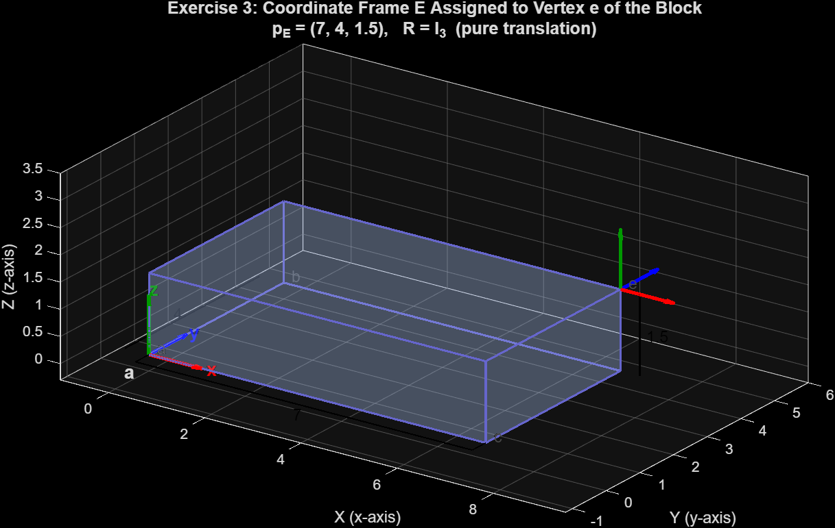
Figure 3

5.4 Exercise 4: Kinematic Transformation of Displaced Coordinate Frames
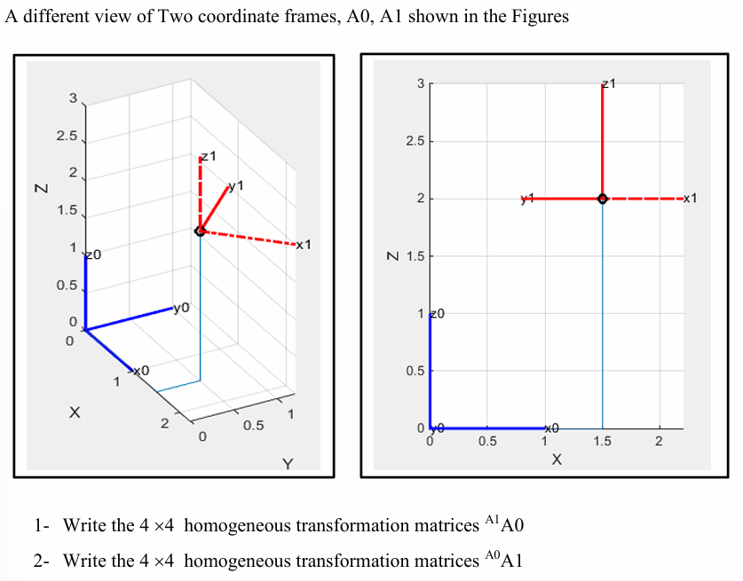
The position of the origin of frame {1} relative to frame {0} is p₁ = (1.5, 0.5, 2) relative to frame {0}.
Visual analysis of the grid gives: x₁ aligns with global −Y, y₁ aligns with global +X, and z₁ aligns with global +Z. The rotation matrix mapping these is:
R =
[ 0, 1, 0
−1, 0, 0
0, 0, 1 ]
∴ ᴬ⁰TA₁ =
[ 0, 1, 0, 1.5
−1, 0, 0, 0.5
0, 0, 1, 2
0, 0, 0, 1 ]
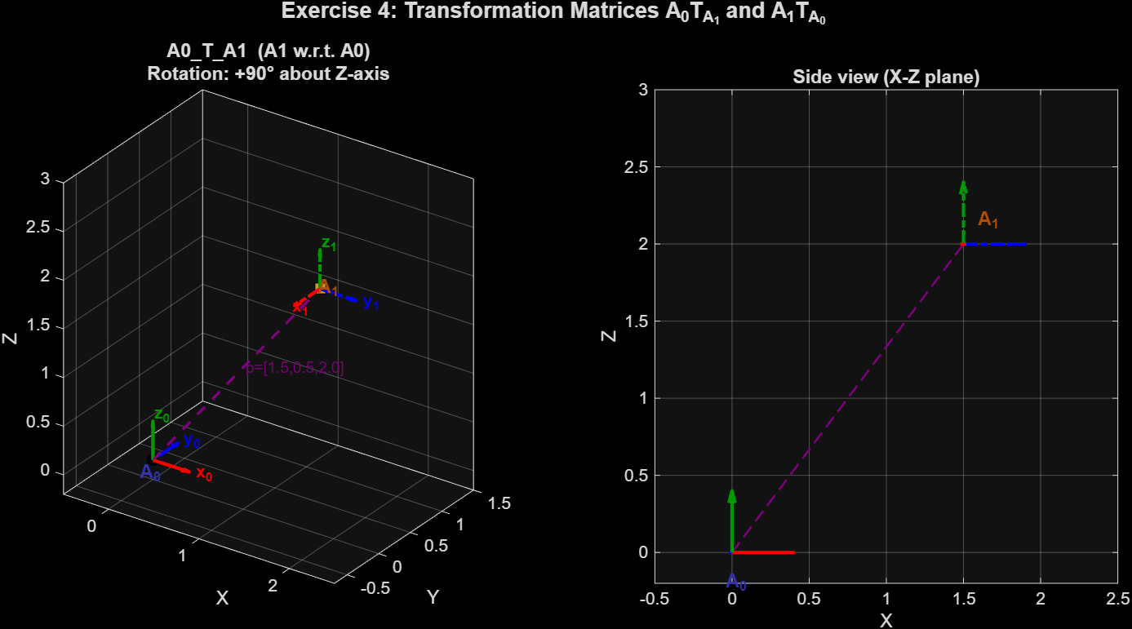
Figure 4

The inverse ᴬ¹TA₀ was obtained by applying Corollary 1:
Rᵀ =
[ 0, −1, 0
1, 0, 0
0, 0, 1 ]
−Rᵀp = [ −0.5, −1.5, −2 ]ᵀ → −Rᵀp = [ 1.5, 0.5, 0 ]ᵀ
∴ ᴬ¹TA₀ =
[ 0, −1, 0, 1.5
1, 0, 0, 0.5
0, 0, 1, −2
0, 0, 0, 1 ]
============================================================
Exercise 4: Transformation Matrices for Frames A0 and A1
============================================================
--- Verification R ∈ SO(3) ---
R^T * R =
1 0 0
0 1 0
0 0 1
det(R) = 1.000000 (should be +1)
Cross-check: x1 x y1 = [-0, 0, 1] == z1 = [0, 0, 1] -->
Cross-check: x1 x y1 = [80, 65, 83] == z1 = [83, 70, 65] --> IL
Translation p (origin of A1 relative to A0):
p = [1.5, 0.5, 2.0]^T
Rotation matrix R:
0 1 0
-1 0 0
0 0 1
Forward transformation A0_T_A1:
0 1.0000 0 1.5000
-1.0000 0 0 0.5000
0 0 1.0000 2.0000
0 0 0 1.0000
Analytical inverse A1_T_A0:
R^T =
0 -1 0
1 0 0
0 0 1
-R^T * p = [0.5, -1.5, -2.0]^T
A1_T_A0 =
0 -1.0000 0 0.5000
1.0000 0 0 -1.5000
0 0 1.0000 -2.0000
0 0 0 1.0000
MATLAB inv() result (verification):
0 -1.0000 0 0.5000
1.0000 0 0 -1.5000
0 0 1.0000 -2.0000
0 0 0 1.0000
Max error vs analytical: 0.00e+00
Verification A0_T_A1 * A1_T_A0 (should be I_4):
1 0 0 0
0 1 0 0
0 0 1 0
0 0 0 1

>>

5.5 Exercise 5: Second Frame Configuration
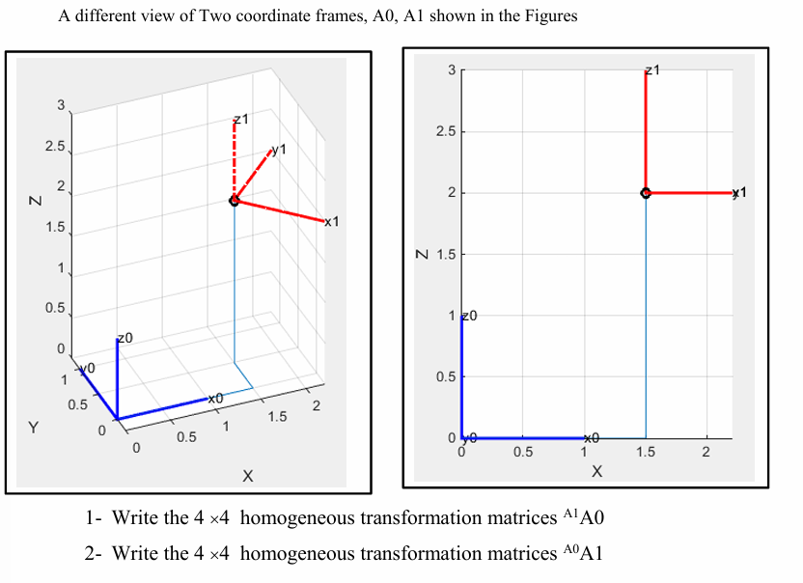
This exercise presents a different orientation of frame A₁ with the same frame A₀. The position of the origin of frame {1} relative to frame {0} is p₁ = (1.5, 0.5, 2) relative to frame {0}.
From the diagram, x₁ aligns with global +X, y₁ aligns with global +Z, and z₁ aligns with global +Y. A parity check reveals:
x₁ × y₁ = (+X) × (+Z) = −Y, but z₁ is drawn as +Y
This is a contradiction since the frame as drawn is a left-handed system with det(R) = −1, placing it outside SO(3). The report proceeds algebraically as drawn to illustrate the anomaly:
R_improper =
[ 1, 0, 0
0, 0, 1
0, 1, 0 ]
→ det = −1
ᴬ⁰TA₁ =
[ 1, 0, 0, 1.5
0, 0, 1, 0.5
0, 1, 0, 2
0, 0, 0, 1 ]
============================================================
Exercise 5: Second Frame Configuration + Parity Analysis
============================================================
--- Parity Analysis ---
x1 = [1, 0, 0]
y1 = [0, 0, 1]
z1 (as drawn) = [0, 1, 0]
x1 x y1 (right-hand rule) = [0, -1, 0]
*** ANOMALY DETECTED ***
The drawn Z-axis [0,1,0] does NOT match the RHR result [0,-1,0].
This is a LEFT-HANDED coordinate system.
det(R_improper) = -1.000000 (should be +1 for SO(3), is -1 here)
Forward transformation A0_T_A1 (as drawn, improper rotation):
1.0000 0 0 1.5000
0 0 1.0000 0.5000
0 1.0000 0 2.0000
0 0 0 1.0000
R^T =
1 0 0
0 0 1
0 1 0
-R^T * p = [-1.5, -2.0, -0.5]^T
Inverse transformation A1_T_A0:
1.0000 0 0 -1.5000
0 0 1.0000 -2.0000
0 1.0000 0 -0.5000
0 0 0 1.0000
Verification A0_T_A1 * A1_T_A0 (should be I_4):
1 0 0 0
0 1 0 0
0 0 1 0
0 0 0 1
MATLAB inv() cross-check:
1.0000 0 0 -1.5000
0 0 1.0000 -2.0000
0 1.0000 0 -0.5000
0 0 0 1.0000
--- Corrected Frame (enforcing right-hand rule) ---
Corrected z1 = x1 x y1 = [0, -1, 0]
det(R_correct) = 1.000000
Corrected A0_T_A1:
1.0000 0 0 1.5000
0 0 -1.0000 0.5000
0 1.0000 0 2.0000
0 0 0 1.0000

>>

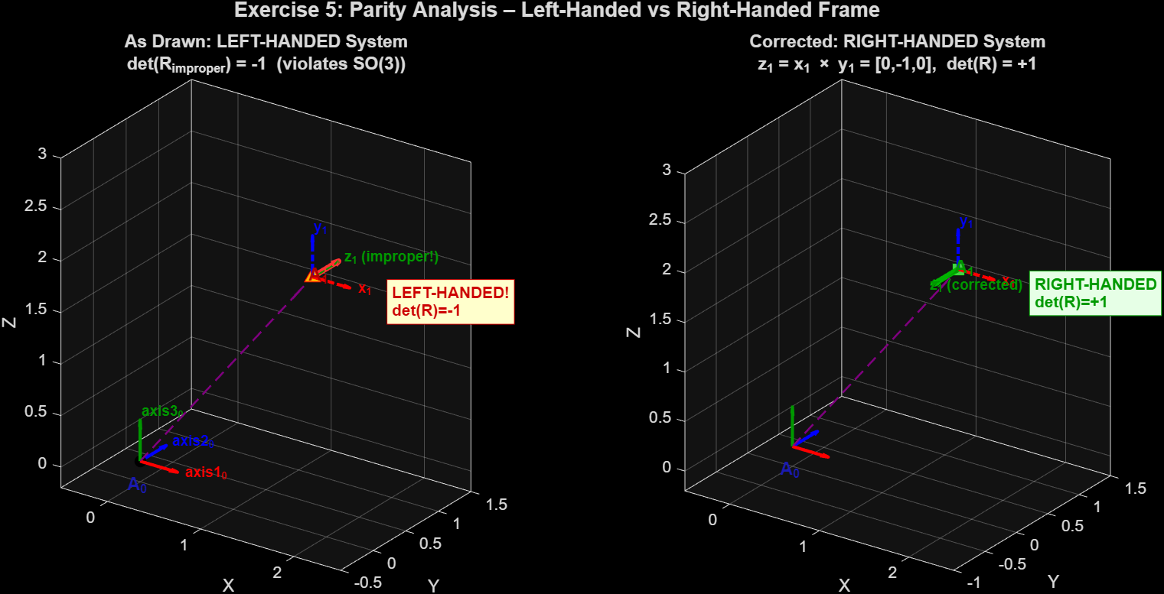
Figure 5

6. Discussion
The analytical findings from this laboratory exercise validate the theoretical underpinnings of spatial kinematics, rotation formalisms, and homogeneous geometry.
Exercise 1 directly demonstrated the critical role of the right-hand rule in maintaining the fundamental topology of the SO(3) Lie group. The MATLAB implementation using the cross() function validated this result numerically.
The application of Corollary 1 in Exercise 2 robustly demonstrated the SE(3) inversion. By isolating R and exploiting R⁻¹ = Rᵀ, the entire inverse mapping ᴮTA was generated without a single division operation beyond the translation computation −Rᵀp. The rotation R was identified as Rₓ(45°) since cos(45°) = sin(45°) = 1/√2.
This efficiency is critical in industrial robotics where embedded controllers must execute kinematic inversions at high frequencies during real-time obstacle avoidance, visual servoing, or SLAM operations.
Exercise 3 demonstrated a boundary case of Chasles' Theorem: when the rotational displacement is zero, the screw motion reduces to pure translation. The 4×4 matrix simplifies to an identity rotation augmented by the physical position vector pE = (7, 4, 1.5)ᵀ. This reinforces the versatility of the SE(3) matrix format, which can represent pure translations, pure rotations, and complex screw combinations in a single unified structure.
Exercise 4 required constructing a rotation matrix from visual axis alignments extracted from a 3D grid. The mapping — x₁ → −Y, y₁ → +X, z₁ → +Z corresponds to a rotation of +90° about the Z-axis, consistent with Euler's Rotation Theorem. The Z-axis remains the invariant rotation axis since z₁ = [0,0,1]ᵀ is unchanged between the two frames. The forward and inverse matrices were then verified computationally using MATLAB.
Exercise 5 exposed a critical anomaly: the coordinate frame as drawn violates the right-hand rule, producing det(R) = −1. This constitutes an improper rotation, a spatial reflection, which falls outside SO(3). In practice, such an error, arising from a diagrammatic mistake or a misconfigured hardware sensor, would cause catastrophic failures in inverse kinematics solvers. This is because Jacobian mapping algorithms, and motion planners, as physical robotic linkages cannot undergo parity inversion.

7. Sources of Error
- Code Input Errors: Since the exercises were verified computationally in MATLAB, typographical errors in entering matrix values represent a practical error source. All data was counterchecked to minimise this risk.

8. Conclusion
This laboratory exercise successfully reinforced the rigorous formalisms governing rigid body translation and orientation in modern spatial kinematics. By manually extracting coordinate data, constructing, and analytically inverting multiple 4×4 homogeneous transformation matrices, the practical application of the SO(3) and SE(3) matrix Lie groups was validated both analytically and computationally using MATLAB.
Anomalous geometric states, such as the parity inversion detected in Exercise 5, were identified and analysed, definitively proving the necessity of strict mathematical verification, specifically the right-hand rule, within computer vision and robotic motion planning architectures.
For future work, it is recommended to explore singularity-free spatial representations such as unit quaternions or Euler parameters to circumvent gimbal lock encountered when parameterising SO(3) via Euler angles. Additionally, implementing active numerical renormalisation algorithms within matrix calculators is advised to continuously mitigate the floating-point orthogonal drift identified in the error analysis.

9. References
[1] P. Corke, W. Jachimczyk, and R. Pillat, Robotics, Vision and Control: Fundamental Algorithms in MATLAB®, vol. 147, Springer Tracts in Advanced Robotics. Cham: Springer International Publishing, 2023, pp. 13–58. doi: 10.1007/978-3-031-07262-8.
[2] B. Siciliano, L. Sciavicco, L. Villani, and G. Oriolo, Robotics: Modelling, Planning and Control, Springer, 2009, pp. 41–72.
[3] J. J. Craig, Introduction to Robotics: Mechanics and Control, 3rd ed. Upper Saddle River, NJ: Pearson Prentice Hall, 2005, pp. 19–55.

Appendix
Python equivalent of all five MATLAB exercises.

import numpy as np
import matplotlib.pyplot as plt
from mpl_toolkits.mplot3d import Axes3D
from mpl_toolkits.mplot3d.art3d import Poly3DCollection
import matplotlib.patches as mpatches

# Helper utilities

def draw_frame(ax, origin, R, scale=0.4, linestyle='-', lw=2, labels=None, label_offset=0.07):
"""Draw a coordinate frame as three coloured arrows."""
colors = ['r', 'b', 'g']
default_labels = ['x', 'y', 'z']
if labels is None:
labels = default_labels
for i in range(3):
d = R[:, i]
ax.quiver(origin[0], origin[1], origin[2],
d[0], d[1], d[2],
length=scale, color=colors[i], linewidth=lw,
linestyle=linestyle, arrow_length_ratio=0.3, normalize=True)
ep = np.array(origin) + (scale + label_offset) * d
ax.text(ep[0], ep[1], ep[2], labels[i],
fontsize=10, color=colors[i], fontweight='bold')

def T_inv(T):
"""Analytical inverse of a 4x4 homogeneous transformation matrix."""
R = T[:3, :3]
p = T[:3, 3]
RT = R.T
return np.block([[RT, (-RT @ p).reshape(3, 1)],
[np.zeros((1, 3)), np.ones((1, 1))]])

# EXERCISE 1 – Right-Hand Rule
print("=" * 60)
print(" Exercise 1: Right-Hand Rule – Z-Axis Determination")
print("=" * 60)

# Frame A1: X→right, Y→down
X1 = np.array([1., 0., 0.])
Y1 = np.array([0., -1., 0.])
Z1 = np.cross(X1, Y1)
print(f"\nFrame A1: X1={X1}, Y1={Y1}")
print(f" Z1 = X1 × Y1 = {Z1} → INTO the page")

# Frame A2: X→right, Y→up
X2 = np.array([1., 0., 0.])
Y2 = np.array([0., 1., 0.])
Z2 = np.cross(X2, Y2)
print(f"\nFrame A2: X2={X2}, Y2={Y2}")
print(f" Z2 = X2 × Y2 = {Z2} → OUT OF the page\n")

fig1, axes = plt.subplots(1, 2, figsize=(12, 5),
subplot_kw={'projection': '3d'})
fig1.suptitle("Exercise 1: Coordinate Frames A₁ and A₂ – Right-Hand Rule",
fontsize=13, fontweight='bold')

for ax, (X, Y, Z, title, into) in zip(axes, [
(X1, Y1, Z1, r"Frame A₁: Z₁ = X₁ × Y₁ = [0,0,−1] (into page)", True),
(X2, Y2, Z2, r"Frame A₂: Z₂ = X₂ × Y₂ = [0,0,+1] (out of page)", False)
]):
R = np.column_stack([X, Y, Z])
draw_frame(ax, [0, 0, 0], R, scale=0.65,
labels=['X', 'Y', 'Z'])
# Annotate Z symbol
theta = np.linspace(0, 2 * np.pi, 100)
r = 0.12
cx = r * np.cos(theta)
cy = r * np.sin(theta)
ax.plot(cx, cy, [0.72] * 100, 'g--', lw=1.2)
if into:
ax.plot([-0.06, 0.06], [0.06, -0.06], [0.72, 0.72], 'g-', lw=2)
ax.plot([-0.06, 0.06], [-0.06, 0.06], [0.72, 0.72], 'g-', lw=2)
else:
ax.scatter([0], [0], [0.72], color='g', s=80, zorder=5)
ax.set_xlabel('X'); ax.set_ylabel('Y'); ax.set_zlabel('Z')
ax.set_title(title, fontsize=10, fontweight='bold')
ax.set_xlim(-0.8, 1.0); ax.set_ylim(-1.1, 0.6); ax.set_zlim(-0.2, 1.1)
ax.view_init(elev=25, azim=30)

plt.tight_layout()
plt.savefig('figure_ex1_coordinate_frames.png', dpi=150, bbox_inches='tight')
print("Figure saved: figure_ex1_coordinate_frames.png")

# EXERCISE 2 – Homogeneous Matrix Inversion
print("\n" + "=" * 60)
print(" Exercise 2: Homogeneous Transformation Matrix Inversion")
print("=" * 60)

s = 1 / np.sqrt(2)
A_T_B = np.array([
[1., 0., 0., 3.],
[0., s, -s, 5.],
[0., s, s, 7.],
[0., 0., 0., 1.]
])
print("\nForward transformation A_T_B:\n", A_T_B)

R2 = A_T_B[:3, :3]
p2 = A_T_B[:3, 3]
print(f"\nR =\n{R2}")
print(f"p = {p2}")
print(f"\ndet(R) = {np.linalg.det(R2):.6f} (should be +1)")
print(f"R^T R =\n{np.round(R2.T @ R2, 10)}")

B_T_A = T_inv(A_T_B)
print(f"\nAnalytical inverse B_T_A:\n{B_T_A}")
print(f"\n-R^T p = {-R2.T @ p2}")
print(f" Exact: [-3, {-6*np.sqrt(2):.4f}, {-np.sqrt(2):.4f}]")
print(f"\nVerification A_T_B * B_T_A:\n{np.round(A_T_B @ B_T_A, 10)}")

fig2, (ax2a, ax2b) = plt.subplots(1, 2, figsize=(11, 5),
subplot_kw={'projection': '3d'})
fig2.suptitle("Exercise 2: Forward and Inverse Homogeneous Transformations",
fontsize=13, fontweight='bold')

# Frame A at origin
draw_frame(ax2a, [0, 0, 0], np.eye(3), scale=0.8, linestyle='--',
labels=['X_A', 'Y_A', 'Z_A'])
# Frame B at p
draw_frame(ax2a, p2, R2, scale=0.8,
labels=['X_B', 'Y_B', 'Z_B'])
ax2a.scatter(*p2, color='k', s=60)
ax2a.text(*p2 + np.array([0.15, 0, 0.3]), 'Origin_B', fontsize=9)
ax2a.set_xlabel('X'); ax2a.set_ylabel('Y'); ax2a.set_zlabel('Z')
ax2a.set_title("Frame B relative to A (A_T_B)", fontsize=11, fontweight='bold')
ax2a.view_init(elev=25, azim=35)

# Frame B at origin (B perspective)
R_BA = B_T_A[:3, :3]
p_AB = B_T_A[:3, 3]
draw_frame(ax2b, [0, 0, 0], np.eye(3), scale=0.8, linestyle='--',
labels=["X_B", "Y_B", "Z_B"])
draw_frame(ax2b, p_AB, R_BA, scale=0.8,
labels=["X_A", "Y_A", "Z_A"])
ax2b.scatter(*p_AB, color='k', s=60)
ax2b.text(*p_AB + np.array([0.15, 0, 0.3]), 'Origin_A', fontsize=9)
ax2b.set_xlabel("X'"); ax2b.set_ylabel("Y'"); ax2b.set_zlabel("Z'")
ax2b.set_title("Frame A relative to B (B_T_A)", fontsize=11, fontweight='bold')
ax2b.view_init(elev=25, azim=35)

plt.tight_layout()
plt.savefig('figure_ex2_matrix_inversion.png', dpi=150, bbox_inches='tight')
print("Figure saved: figure_ex2_matrix_inversion.png")

# EXERCISE 3 – Block Frame Assignment
print("\n" + "=" * 60)
print(" Exercise 3: Frame Assignment on a Rectangular Block")
print("=" * 60)

Lx, Ly, Lz = 7., 4., 1.5
p_E = np.array([Lx, Ly, Lz])
R_E = np.eye(3)
A_T_E = np.vstack([np.hstack([R_E, p_E.reshape(3, 1)]), [0, 0, 0, 1]])
E_T_A = T_inv(A_T_E)

print(f"\nCuboid dimensions: Lx={Lx}, Ly={Ly}, Lz={Lz}")
print(f"Frame E origin: p_E = {p_E}")
print(f"\nA_T_E:\n{A_T_E}")
print(f"\nE_T_A (inverse):\n{E_T_A}")
print(f"\nVerification: A_T_E * E_T_A =\n{np.round(A_T_E @ E_T_A, 10)}")

fig3 = plt.figure(figsize=(9, 7))
ax3 = fig3.add_subplot(111, projection='3d')

# Draw cuboid
verts = np.array([
[0, 0, 0], [Lx, 0, 0], [Lx, Ly, 0], [0, Ly, 0],
[0, 0, Lz], [Lx, 0, Lz], [Lx, Ly, Lz], [0, Ly, Lz]
])
edges = [(0,1),(1,2),(2,3),(3,0),(4,5),(5,6),(6,7),(7,4),
(0,4),(1,5),(2,6),(3,7)]
for e in edges:
ax3.plot3D(*zip(verts[e[0]], verts[e[1]]), color=(0.4, 0.4, 0.8), lw=1.5)

# Transparent faces
faces = [[0,1,2,3],[4,5,6,7],[0,1,5,4],[3,2,6,7],[0,3,7,4],[1,2,6,5]]
poly = Poly3DCollection([[verts[f] for f in face] for face in faces],
alpha=0.12, facecolor=(0.7, 0.8, 1.0), edgecolor='none')
ax3.add_collection3d(poly)

# Frame A
draw_frame(ax3, [0, 0, 0], np.eye(3), scale=1.1,
labels=['x', 'y', 'z'])
ax3.text(-0.3, -0.4, -0.3, 'a', fontsize=13, fontweight='bold')
ax3.text(-0.6, -0.5, 0.1, 'Frame A', fontsize=10, color='navy', fontweight='bold')

# Frame E
draw_frame(ax3, p_E, np.eye(3), scale=1.1,
labels=['eₓ', 'eᵧ', 'e_z'])
ax3.text(Lx - 0.3, Ly + 0.1, Lz - 0.3, 'e', fontsize=13, fontweight='bold')
ax3.text(Lx + 0.2, Ly - 0.5, Lz + 0.2, 'Frame E', fontsize=10, color='darkred', fontweight='bold')

ax3.set_xlabel('X (x-axis)'); ax3.set_ylabel('Y (y-axis)'); ax3.set_zlabel('Z (z-axis)')
ax3.set_title(f"Exercise 3: Frame E at vertex e — pₑ=({Lx},{Ly},{Lz}), R=I₃",
fontsize=12, fontweight='bold')
ax3.view_init(elev=22, azim=35)

plt.tight_layout()
plt.savefig('figure_ex3_block_frame.png', dpi=150, bbox_inches='tight')
print("Figure saved: figure_ex3_block_frame.png")

# EXERCISE 4 – Two Frames (valid SO(3))
print("\n" + "=" * 60)
print(" Exercise 4: Transformation Matrices for Frames A0 and A1")
print("=" * 60)

p4 = np.array([1.5, 0.5, 2.0])
x1_4 = np.array([0., -1., 0.])
y1_4 = np.array([1., 0., 0.])
z1_4 = np.array([0., 0., 1.])
R4 = np.column_stack([x1_4, y1_4, z1_4])

z_check = np.cross(x1_4, y1_4)
print(f"\ndet(R) = {np.linalg.det(R4):.6f}")
print(f"x1×y1 = {z_check} == z1 = {z1_4} → {np.allclose(z_check, z1_4)}")

A0_T_A1 = np.vstack([np.hstack([R4, p4.reshape(3,1)]), [0,0,0,1]])
A1_T_A0 = T_inv(A0_T_A1)

print(f"\nR =\n{R4}")
print(f"\nA0_T_A1:\n{A0_T_A1}")
print(f"\nA1_T_A0:\n{A1_T_A0}")
print(f"\nVerification:\n{np.round(A0_T_A1 @ A1_T_A0, 10)}")

fig4, (ax4a, ax4b) = plt.subplots(1, 2, figsize=(12, 5),
subplot_kw={'projection': '3d'})
fig4.suptitle("Exercise 4: Transformation Matrices A₀T_{A₁} and A₁T_{A₀}",
fontsize=13, fontweight='bold')

scl4 = 0.4
o0_4 = np.zeros(3)

# 3D perspective view
draw_frame(ax4a, o0_4, np.eye(3), scale=scl4,
labels=['x₀','y₀','z₀'])
ax4a.text(-0.05, -0.15, -0.2, 'A₀', fontsize=11, fontweight='bold', color='navy')
draw_frame(ax4a, p4, R4, scale=scl4, linestyle='-.',
labels=['x₁','y₁','z₁'])
ax4a.text(p4[0]+0.08, p4[1]-0.2, p4[2]+0.1, 'A₁', fontsize=11, fontweight='bold', color='darkred')
ax4a.quiver(*o0_4, *p4, length=0.95, color='purple', linewidth=1.5,
linestyle='--', arrow_length_ratio=0.1, normalize=True)
ax4a.text(p4[0]/2+0.1, p4[1]/2, p4[2]/2+0.1,
f'p=[{p4[0]},{p4[1]},{p4[2]}]', fontsize=9, color='purple')
ax4a.set_xlabel('X'); ax4a.set_ylabel('Y'); ax4a.set_zlabel('Z')
ax4a.set_title("A₀T_{A₁}: A1 w.r.t. A0\n(+90° rotation about Z)", fontsize=11, fontweight='bold')
ax4a.set_xlim(-0.5,2.5); ax4a.set_ylim(-0.8,1.3); ax4a.set_zlim(-0.2,3.0)
ax4a.view_init(elev=28, azim=35)

# Side view
draw_frame(ax4b, o0_4, np.eye(3), scale=scl4, labels=['x₀','y₀','z₀'])
draw_frame(ax4b, p4, R4, scale=scl4, linestyle='-.', labels=['x₁','y₁','z₁'])
ax4b.plot3D(*zip(o0_4, p4), '--', color='purple', lw=1.2)
ax4b.set_xlabel('X'); ax4b.set_ylabel('Y'); ax4b.set_zlabel('Z')
ax4b.set_title("Side View (X–Z plane)", fontsize=11, fontweight='bold')
ax4b.set_xlim(-0.5,2.5); ax4b.set_ylim(-0.5,1); ax4b.set_zlim(-0.2,3.0)
ax4b.view_init(elev=0, azim=0)

plt.tight_layout()
plt.savefig('figure_ex4_frames_A0_A1.png', dpi=150, bbox_inches='tight')
print("Figure saved: figure_ex4_frames_A0_A1.png")

# EXERCISE 5 – Parity Analysis (Left-Handed vs Right-Handed)
print("\n" + "=" * 60)
print(" Exercise 5: Second Frame Configuration & Parity Analysis")
print("=" * 60)

p5 = np.array([1.5, 0.5, 2.0])
x1_5 = np.array([1., 0., 0.])
y1_5 = np.array([0., 0., 1.])
z1_5 = np.array([0., 1., 0.]) # as drawn – WRONG
z_rhr = np.cross(x1_5, y1_5) # correct by RHR
R_imp = np.column_stack([x1_5, y1_5, z1_5])
R_cor = np.column_stack([x1_5, y1_5, z_rhr])

print(f"\nDrawn z1 = {z1_5}")
print(f"RHR z1 = {z_rhr} (x1 × y1)")
print(f"det(R_improper) = {np.linalg.det(R_imp):.6f} → LEFT-HANDED")
print(f"det(R_correct) = {np.linalg.det(R_cor):.6f} → RIGHT-HANDED")

A0_T_A1_imp = np.vstack([np.hstack([R_imp, p5.reshape(3,1)]), [0,0,0,1]])
A1_T_A0_imp = T_inv(A0_T_A1_imp)
print(f"\nA0_T_A1 (improper):\n{A0_T_A1_imp}")
print(f"\nA1_T_A0 (improper):\n{A1_T_A0_imp}")
print(f"\nVerification:\n{np.round(A0_T_A1_imp @ A1_T_A0_imp, 10)}")

fig5, (ax5a, ax5b) = plt.subplots(1, 2, figsize=(12, 5),
subplot_kw={'projection': '3d'})
fig5.suptitle("Exercise 5: Parity Analysis – Left-Handed vs Right-Handed Frame",
fontsize=13, fontweight='bold')

scl5 = 0.4
o0_5 = np.zeros(3)

for ax5, R5, title5, marker_color, anno in [
(ax5a, R_imp, "As Drawn: LEFT-HANDED\ndet(R) = −1 (violates SO(3))", 'red',
("LEFT-HANDED!\ndet(R)=−1", [1,0,0], [0.9,1,0.9][::-1])),
(ax5b, R_cor, "Corrected: RIGHT-HANDED\ndet(R) = +1 (valid SO(3))", 'green',
("RIGHT-HANDED\ndet(R)=+1", [0,0.6,0], [0.9,1,0.9]))
]:
draw_frame(ax5, o0_5, np.eye(3), scale=scl5, labels=['x₀','y₀','z₀'])
ax5.text(-0.05, -0.15, -0.2, 'A₀', fontsize=11, fontweight='bold', color='navy')
draw_frame(ax5, p5, R5, scale=scl5, linestyle='-.', labels=['x₁','y₁','z₁'])
ax5.scatter(*p5, color=marker_color, s=80, marker='^', zorder=5)
ax5.text(p5[0]+0.08, p5[1]-0.2, p5[2]+0.1, 'A₁', fontsize=11,
fontweight='bold', color=marker_color)
ax5.plot3D(*zip(o0_5, p5), '--', color='purple', lw=1.2)
ax5.set_xlabel('X'); ax5.set_ylabel('Y'); ax5.set_zlabel('Z')
ax5.set_title(title5, fontsize=11, fontweight='bold')
ax5.set_xlim(-0.5,2.5); ax5.set_ylim(-0.6,1.5); ax5.set_zlim(-0.2,3.0)
ax5.view_init(elev=25, azim=35)

plt.tight_layout()
plt.savefig('figure_ex5_parity_analysis.png', dpi=150, bbox_inches='tight')
print("Figure saved: figure_ex5_parity_analysis.png")

print("\n" + "=" * 60)
print(" All exercises complete. Five figures generated.")
print("=" * 60)
plt.show()

